

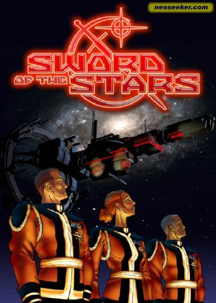

**GAME MANUAL**

**Installation**

1. Download CodeBlocks from <http://www.codeblocks.org>.
2. Download and install GLUT from <http://www.sci.brooklyn.cuny.edu/~goetz/codeblocks/glut/>.
3. Start CodeBlocks, and open the file named GLUT_1.cbp.
4. Click “Run”, the green play button on the top left and begin playing!

**Background**

A long time ago in a galaxy far, far away…. This game takes place in a solar system like ours in an ancient and obscure corner of the universe. The Terran Empire has, through many centuries of human hegemony, established a strong presence on not only their home planet, the Earth, but also the neighbouring Mars that had been terraformed by the expansionist ideal of the absolute government. Under the direction of its supreme commander, a former lifeless planet was transformed into a blue planet that housed many colonists made to inhabit the Empire’s second home. The colonists and the workers are not happy however, since their efforts were rewarded only with more orders to carry out and more toil to be had. Desperately seeking freedom, the people of Mars started to plot against the Empire, and formed a secret group that included some of the most influential military commanders at the new base on Mars. When the plan was ripe, they carried out a spectacular operation that saw every loyalist position on the planet disabled, and destroyed many imperial space stations in orbit around Mars. The Terran Empire, seeing that the longevity of the peace of humanity is about to be broken, declared a total war against the Martians, bringing out all of its reserve forces under the command of the Terrans’ most prominent general. It is an all out struggle between the two nations to see whose ideal and tactics will emerge victorious.

**Instructions**

*Throughout the duration of the game, the program can be paused by pressing the SPACEBAR key, and can be exited by pressing the ESC key.*

**Upgrade Screen**

After the crawl text, which can be skipped by the ENTER key, the game will start with the upgrade screen.

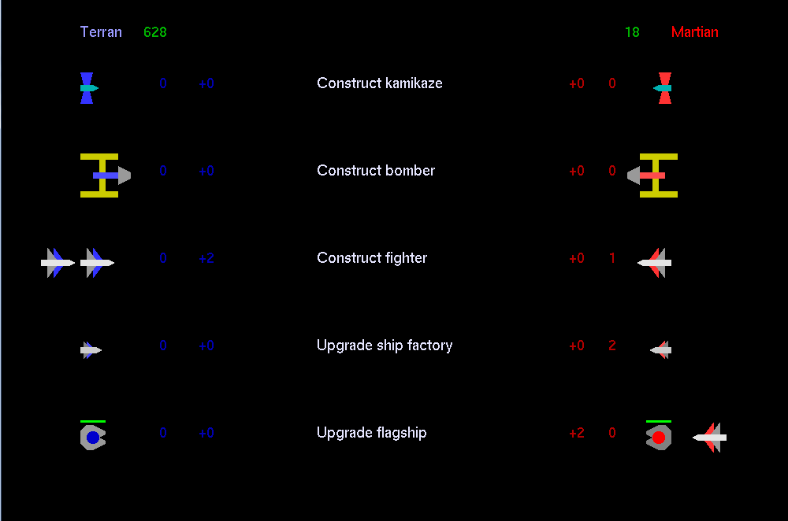

On this screen, both the Terran side (blue), and the Martian side (red), can select upgrades or buy ships for their own side. The digit without the ‘+’ sign is their current upgrade level, and the digit with the ‘+’ sign is how many levels of upgrades they have chosen. Each upgrade comes with a price, which will automatically be deducted from the player’s treasury in green at the top of the screen. Any unspent resources will gather a 10% interest from the treasury shown when the purchases are finalized.

Upgrade Screen Controls

|  |  |  |
| --- | --- | --- |
| Action | Terran Key | Martian Key |
| move selection ship up or down | w/s | UP key/DOWN key |
| buy/cancel proposed upgrades | a/d | LEFT key/RIGHT key |
| finalize upgrades to go to next round | ENTER key | |

Upgrades

Construct kamikaze – This will increase the number of kamikaze ships in stock. A kamikaze ship does not fire against other ships, but flies to the other base for a massive bombardment attack against either the shields or the base itself.

Construct bomber – This increases the stock of bombers. A bomber is a very robust ship that moves slowly and fires slow but powerful shots. Should a bomber’s shot reach the other base’s shield or planet, it will cause massive bombardment damage.

Construct fighter – This increases the number of fighters in stock. A fighter is a sturdy and fast-moving ship that fires rapid-moving shots. Although weak against shields, they are able to withstand fire from regular ships and return powerful shots against ships of any type.

Upgrade ship factory – This upgrade increases the chance of a regular ship spawning for one side. Regular ships are small and fire weak shots, but can be overwhelming when in large numbers. They are useful against enemy ships and blocking powerful shots from bombers.

Upgrade flagship – This upgrade increases the health and maximum temperature-tolerance of the flagship. The flagship can sustain more hits and can fire more successive shots. A higher upgraded flagship is also capable of summoning kamikaze, bomber, or fighter ships in stock faster into the battle.

**War Screen**

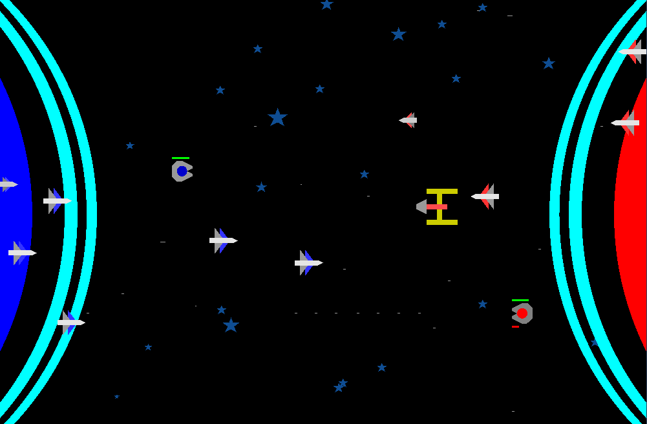

When the upgrades have been finalized and both players have chosen to go to the next round, the war screen will appear. The flagship uniquely has a circle representing the side’s colour in the middle of the ship’s body, and can be controlled by the following keys.

|  |  |  |
| --- | --- | --- |
| Action | Terran Key | Martian Key |
| move ship up/down/left/right | w/s/a/d | UP key/DOWN key/LEFT key/RIGHT key |
| fire | 1 | / |

*None of the ships will be able to cross the centre of the screen except for kamikaze ships.*

Throughout the warring period, both sides will be continually spawning regular ships depending on the factory level of each side. If a side has bought special ships, they will spawn according to the flagship level of each side. These ships will move by their own accord, and cannot be controlled by the players.

During this period, the players and their ships are able to take down enemy ships. By taking down these enemy ships, bonus resources will be gained. The more expensive a ship is, the more resources a player will earn from it. Furthermore, if a flagship is destroyed, it will not spawn until the round after the next.

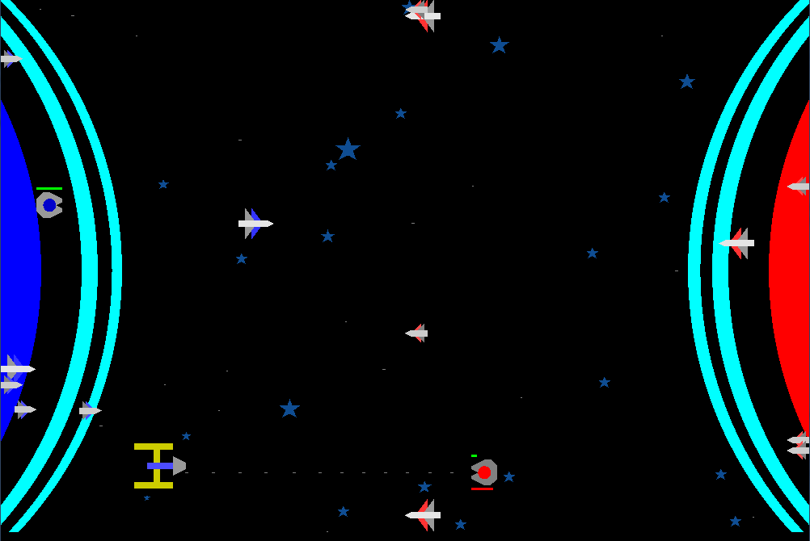

Each side can also destroy the other side’s shields, which will decrease in width as it becomes more damaged. This will not only bring that player closer to victory, it will also allow the side to loot the other player’s resources. The loot will range from 15% to 30% of the treasury of the player at that point in game time.

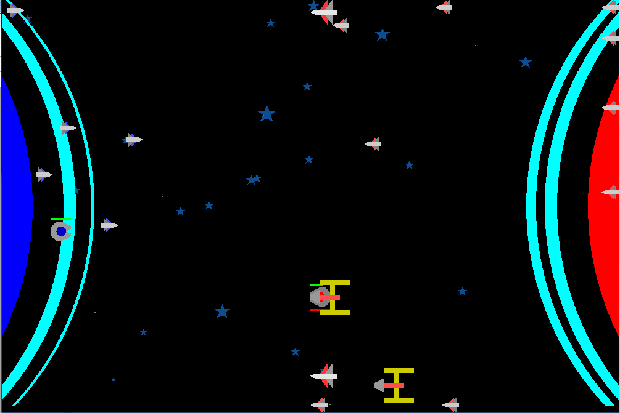 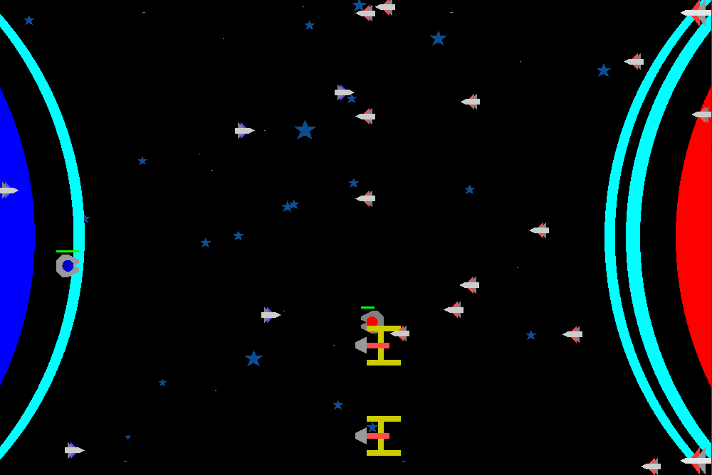

A weakened shield The shield destroyed

After the shields are destroyed, the last goal for a player would be to destroy the opposing side’s base. The base will not have a health bar, but its health can be assessed by how deeply the planet is coloured. The deeper the colour is, the better situation for a planet is; the shallower the colour, the worse the circumstances.

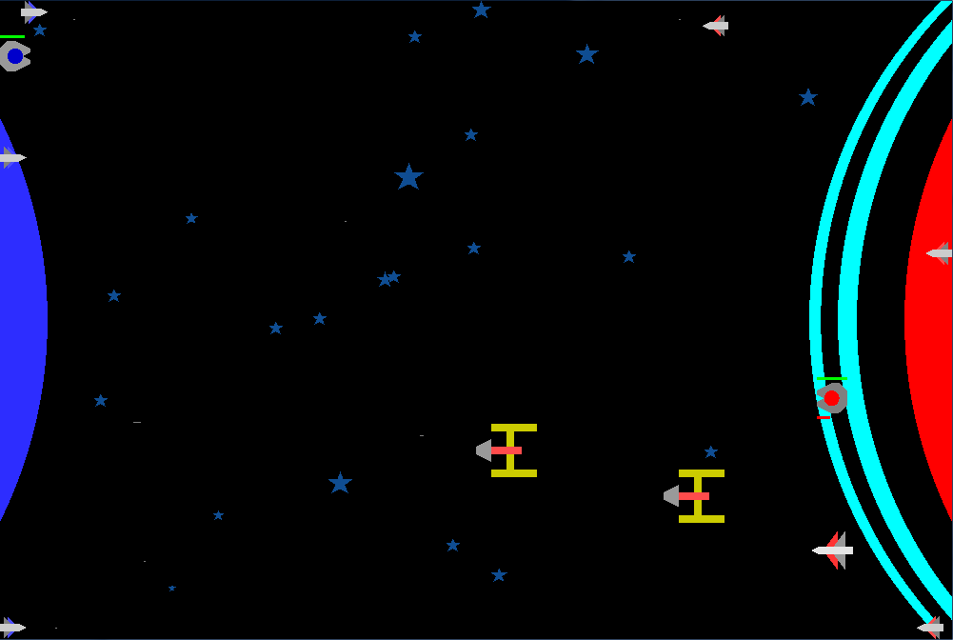 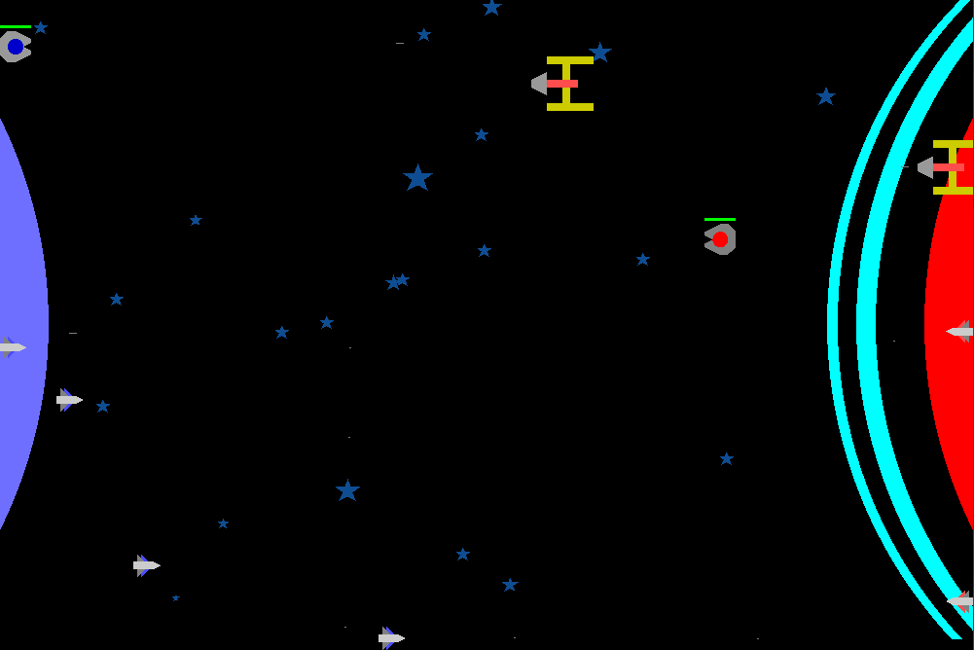

A healthier base The base in a worse situation

Each round will be at least 25 seconds, and will randomly end from that point, which also causes the small regular ships to return to the base. Each side will gain bonus resources for surviving the round, and as the game progresses, each player will gain more resources. The players will then be directed to the upgrade screen where they can choose upgrades for their sides using the resources gained from the round, or leave the treasury to gather interest.

**HAPPY PLAYING!**

